Bridge Pattern
# Source: AI Source: Provided by: [Data Path: Persons Table -> ID Column: 1, Name_En Column: Motasem Essam] -> From: [ChatGPT] on [1/23/2026]
The Bridge Pattern separates an abstraction from its implementation so that the two can vary independently.
👉 Think of it like a TV remote: the remote (abstraction) works for different TV brands (implementations) without changing the remote itself.

🔑 Key Points
# Source: AI Source: Provided by: [Data Path: Persons Table -> ID Column: 1, Name_En Column: Motasem Essam] -> From: [ChatGPT] on [1/23/2026]
• Decouples abstraction from implementation
• Enables independent development and extension
• Useful when you have multiple possible combinations of abstractions and implementations

❌ Bad Example
# Source: AI Source: Provided by: [Data Path: Persons Table -> ID Column: 1, Name_En Column: Motasem Essam] -> From: [ChatGPT] on [1/23/2026]
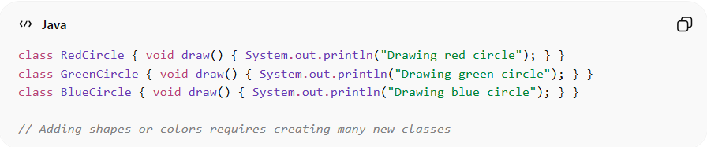
class RedCircle { void draw() { System.out.println("Drawing red circle"); } }
class GreenCircle { void draw() { System.out.println("Drawing green circle"); } }
class BlueCircle { void draw() { System.out.println("Drawing blue circle"); } }

// Adding shapes or colors requires creating many new classes
Problems:
• Class explosion for every shape-color combination
• Hard to maintain or extend
• Abstraction tightly coupled with implementation

✅ Good Example
# Source: AI Source: Provided by: [Data Path: Persons Table -> ID Column: 1, Name_En Column: Motasem Essam] -> From: [ChatGPT] on [1/23/2026]
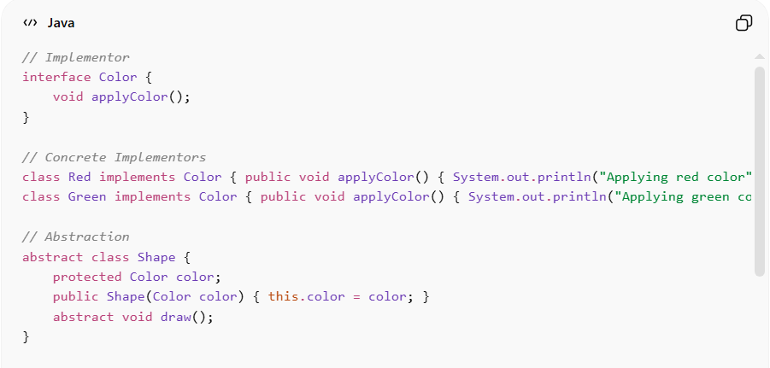
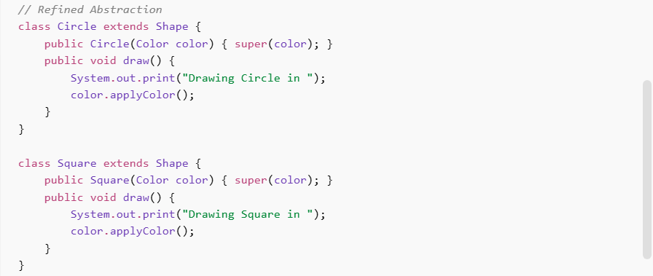
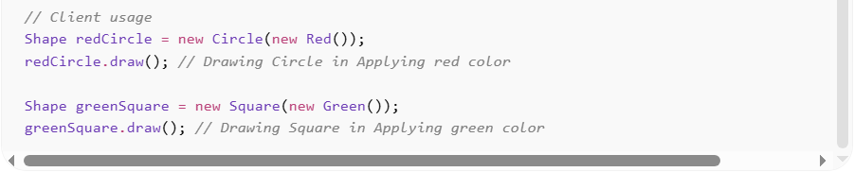
// Implementor
interface Color {
void applyColor();
}

// Concrete Implementors
class Red implements Color { public void applyColor() { System.out.println("Applying red color"); } }
class Green implements Color { public void applyColor() { System.out.println("Applying green color"); } }

// Abstraction
abstract class Shape {
protected Color color;
public Shape(Color color) { this.color = color; }
abstract void draw();
}

// Refined Abstraction
class Circle extends Shape {
public Circle(Color color) { super(color); }
public void draw() {
System.out.print("Drawing Circle in ");
color.applyColor();
}
}

class Square extends Shape {
public Square(Color color) { super(color); }
public void draw() {
System.out.print("Drawing Square in ");
color.applyColor();
}
}

// Client usage
Shape redCircle = new Circle(new Red());
redCircle.draw(); // Drawing Circle in Applying red color

Shape greenSquare = new Square(new Green());
greenSquare.draw(); // Drawing Square in Applying green color
Benefits:
• Abstraction and implementation can vary independently
• Reduces class explosion
• Promotes flexibility and maintainability
• Supports open/closed principle

⚡ Advantages
# Source: AI Source: Provided by: [Data Path: Persons Table -> ID Column: 1, Name_En Column: Motasem Essam] -> From: [ChatGPT] on [1/23/2026]
• Decouples interface from implementation
• Reduces complexity when multiple variations exist
• Improves maintainability and scalability
• Supports runtime binding of implementation

⚠️ Disadvantages
# Source: AI Source: Provided by: [Data Path: Persons Table -> ID Column: 1, Name_En Column: Motasem Essam] -> From: [ChatGPT] on [1/23/2026]
• Increases number of classes and interfaces
• Can make design slightly more complex
• Overhead if the system has simple abstraction

🛠️ Use Cases
# Source: AI Source: Provided by: [Data Path: Persons Table -> ID Column: 1, Name_En Column: Motasem Essam] -> From: [ChatGPT] on [1/23/2026]
• GUI frameworks – windows, buttons with different themes or rendering engines
• Device control – abstraction of devices with multiple implementations (e.g., printers, displays)
• Drawing applications – shapes with multiple colors or rendering styles
• Cross-platform applications – separating API abstraction from platform-specific implementation

